Contents

2 Introduction 3

3 Initial Setup 3

3.1 Dock Power Supply 3

3.2 Wi-Fi Issues 4

3.2.1 Ubiquiti network users 4

3.3 Remote Setup 5

3.4 Settings Menu 5

3.5 Dock Setup 6

3.5.1 Smart Charging Dock status LED codes 6

3.5.2 Dock Discovery & Setup - Ethernet Connection 7

3.5.3 Dock Discovery & Setup - Wi-Fi Connection 8

4 Configuration 9

4.1 Introduction 9

5 Integrations 9

5.1 Apple TV 9

5.2 Android TV 10

5.3 FireTV 10

5.4 Global Cache iTach Devices 10

5.5 Home Assistant 11

5.6 Roon 14

6 User Interface 15

6.1 Overview with an example 15

7 Activities & Macros 16

7.1 Overview 16

7.2 Activities 17

7.2.1 Activity groups 17

7.2.2 Macros 18

8 Tips 18

8.1 General Tips 18

8.2 New Ideas 18

9 UI Design 19

9.1 Introduction 19

9.2 Icon Sources 19

9.3 Modifying Icons 19

9.4 Deleting Icons 19

9.5 Page Design 20

10 Remotes (Infrared) 22

10.1 Process Overview 22

10.2 CSV Files Explained 22

10.3 CSV File Configuration 23

10.4 Converting URC MXD files 23

10.5 IrScruntinizer Tips 24

10.6 Global Cache IR Codes 24

10.7 Importing Remote Codes 25

10.8 Learning Remote Codes 25

10.9 Tip for discrete commands 25

11 APIs 26

11.1 REST 26

12 Maintenance 27

12.1 Replacing the battery 27

# Introduction

This document is a collection of tips posted in the Discord server over several months, as early backers received their rewards and started to set up and configure their remotes. While most of the information is not attributable, there were a handful of members that consistently provided guidance to the community, and it is appreciated. Thank you to kennymc.c, ][alkabout, and va_lemon.

The first stop for a new user should be the official [knowledge base](https://www.unfoldedcircle.com/software-roadmap). However, this document may have some additional information and therefore be useful while the Unfolded Circle team build out their documentation after working hard to ship out the rewards to all backers and tackle their aggressive [software roadmap](https://www.unfoldedcircle.com/software-roadmap).

# Initial Setup

## Dock Power Supply

Users are required to provide the 5.0 VDC, 1.5 Amp (minimum) power supply for the dock. Note that it is fine to have a higher amperage rating, as long as the voltage is 5.0 VDC. If recycling an old power adapter, and the remote control will not charge in the dock (white LED breathing), try another one. I used an old 5.0 VDC, 1.8 A power adapter that did not work. I had another old old 5.0 VDC, 1.5 A power adapter that worked fine.

## Wi-Fi Issues

Some owners mentioned that setting up a 2.4 GHz only network helped with Wi-Fi connection issues, as the Remote Two only supports 2.4 GHz, not 5 GHz. It is possible that connecting to a dual-band network may cause connectivity issues that affect discovery and therefore integration setup.

### Ubiquiti network users

Some owners of Ubiquiti networking hardware using the UniFi software management have reported they had to disable BSS Transition on the Wi-Fi network used for the Remote Two to be able to obtain an IP address. Ubiquiti recommends leaving BSS Transition on, but if connection and/or discovery issues persist, the solution is to create a new Wi-Fi network (with BSS Transition disabled) just for the remote and rather than negatively impact other clients.

The feature is controlled by navigating to the UniFi Settings, selecting “WiFi”, and then the Wi-Fi network used for the Remote Two, and unchecking the box in the Advanced section. Here is a description of the feature.

Personally, I was unable to discover anything via my Ubiquiti network hardware / software. I created a new Wi-Fi network still tied to the same subnet for testing without affecting other clients. I joined the remote to this new Wi-Fi network. Since other users had mentioned that setting up a 2.4 GHz only network worked for them, I turned off the 5 GHz Wi-Fi option, and thereby creating a 2.4 GHz only network. As soon as I turned off the 5 GHz Wi-Fi option, I was able to discover items on my network.

That said, I was attempting an integration of Roon, and still not having success, so I decided to remove the following options in the Ubiquiti UniFi interface for the Wi-Fi that affect client communication.

BSS Transition

I removed the BSS Transition option, which “Improves client transitions between APs when they have a weak signal. Clients that do not support this feature may experience connectivity issues.” Some light research compared this option to fast roaming, which may appear in other routers, but Ubiquiti’s implementation may be different.

Multicast and Broadcast Control

I removed Multicast and Broadcast Control, which is designed to “Only allow specific devices to send broadcast traffic on a WiFi network”. The information pop-up noted that “Things like printers, Airplay, and Chromecast devices should be added to the list of exceptions”.

After making these changes, I rebooted the remote, and the Roon integration was successful. Since I have a new Wi-Fi network only for the Remote, the above options are not necessary.

## Remote Setup

To access the web configurator, go to the remote settings page and use the URL displayed. Note the 4-digit login code required.

After that, this is highly recommended to access the remote control through its IP address as the hostname connection is unstable (i.e., 192.168.1.123/configurator). You can find the IP address from your router as this information is not advertised by the remote control.

The web configurator only works when Remote is awake, so either keep it awake or place it inside the dock for configuration, as this prevents sleep mode.

1. Power on the remote and follow the prompts on the screen.
2. When the option to set up the dock is presented, press skip; we will do this via the web configurator.
3. When the option to set up the integrations is presented, press skip; we will do this via the web configurator.
4. Press the radio button to turn on the web configurator; note the PIN provided.
5. Press Done.
6. Update the firmware.
   1. On the remote, press in the top right corner of the display to access the settings menu.
   2. Select Software Update.
7. Log in to the web configurator via one of two methods.
   1. Via the IP address assigned to the remote (i.e., 192.168.1.123/configurator).
      1. The vendor in the router interface will appear as “Murata Manufacturing Co., Ltd.”.
   2. Via the hostname (i.e. RemoteTwo-d017698526d7/configurator)
8. Continue on to the next section to add a dock.

## Settings Menu

Press on the right top corner of the display to access the settings menu.

## Dock Setup

As of November, 2023, the dock has been challenging to set up for some. If using Wi-Fi, the dock must be ready for setup, with the LED light blinking amber. The dock was exhibiting some weird behavior for me, like it would not cannot enter the ready for setup mode with the remote in the charging cradle, and failure to reset. Your experience may be different. Anyway, here are some recommended steps for setting up the dock.

### Smart Charging Dock status LED codes

|  |  |
| --- | --- |
| Blinking amber | Ready for setup |
| Blinking white | Connecting to network |
| Breathing white | Remote is charging |
| Breathing red | Software update is in progress |
| Solid green | IR learning is on |
| Green blinking twice | IR command received successfully |
| Red blinking twice | IR command receive failed |
| Red, green, blue, yellow blinking | Identify |

### Dock Discovery & Setup - Ethernet Connection

1. Set up the remote control.
2. Connect the dock to Ethernet.
3. Log in to the web configurator.
4. In the web configurator or the remote menu, navigate to Integrations & Docks.
5. Select the + button in the Docks section.
6. Click on “Discover”.
7. The dock should be discovered and appear showing the host name and Wi-Fi MAC address.
8. Click on the discovered dock information box, and select Next.
9. Fill in the required information.
10. Click on Next.
11. The dock will set up and restart.
    1. If the web configurator shows the dock restarting for more than a few minutes, power cycle the dock manually.
    2. If the web configurator shows a message that “Oops! Something went wrong and displays an error such as “Timeout”, power cycle the dock manually.
12. In the web configurator or the remote menu, navigate to Integrations & Docks.
13. You should see the dock.
14. If the dock does not appear, proceed with manual setup.
    1. Obtain the IP address assigned by your router.
       1. The vendor in the router interface will appear as “IKEA Tradfri Hub (Gateway)”.
    2. In the web configurator or the remote menu, navigate to Integrations & Docks.
    3. Select the + button in the Docks section.
    4. Click on “Manual setup”.
    5. Enter the desired name and IP address or hostname.
    6. Click on “Next”.
    7. The dock will restart.
    8. If the process is successful, a “You’re all set!” message will appear.
    9. Click on “Done”.
15. The dock should now appear.
16. Click on the dock, and in the window that opens, check for a firmware update.

### Dock Discovery & Setup - Wi-Fi Connection

1. Set up the remote control.
2. Remove the remote control from the dock.
   1. The dock must be ready for setup (LED light blinking amber), and this does work if the remote is in the dock.
3. Optional: Power off the remote control.
4. Power off the dock.
5. Power on the dock.
   1. If the dock is not ready for setup (LED light blinking amber), factory reset it by inserting a paper clip in the bottom and holding it for ten seconds, then release.
      1. Ensure the paper clip is inserted straight, because if it is inserted at an angle, it may miss the button inside.
6. Power on the remote control if turned off in step 3.
7. Log in to the web configurator.
8. In the web configurator or the remote menu, navigate to Integrations & Docks.
9. Select the + button in the Docks section.
10. Click on “Discover”.
11. The dock should be discovered and appear showing the host name and Wi-Fi MAC address.
12. Click on the discovered dock information box, and select Next.
13. Fill in the required information.
14. Click on Next.
15. The dock will set up and restart.
    1. If the web configurator shows the dock restarting for more than a few minutes, power cycle the dock manually.
    2. If the web configurator shows a message that “Oops! Something went wrong and displays an error such as “Timeout”, power cycle the dock manually.
16. In the web configurator or the remote menu, navigate to Integrations & Docks.
17. You should see the dock.
18. If the dock does not appear, proceed with manual setup.
    1. Obtain the IP address assigned by your router.
       1. The vendor in the router interface will appear as “esp32…”.
    2. In the web configurator or the remote menu, navigate to Integrations & Docks.
    3. Select the + button in the Docks section.
    4. Click on “Manual setup”.
    5. Enter the desired name and IP address or hostname.
    6. Enable the “Setup WiFi” button and enter the SSID and password.
    7. Click on “Next”.
    8. The dock will restart.
    9. If the process is successful, a “You’re all set!” message will appear.
    10. Click on “Done”.
19. The dock should now appear.
20. Click on the dock, and in the window that opens, check for a firmware update.

# Configuration

## Introduction

The overall process involves adding integrations, then setting up the User Interface, then Activities & macros. If IR control is needed, that is accomplished via the Remotes section.

Explanation of activities versus remotes???? Activity groups?

# Integrations

As of march 2024, integrations are singular, except Apple TV integration that can be multiplied if you have several Apple TVs, so for users with multiple Android TV devices, the only way to have 2 is via an external system like home assistant or to create an external driver running on a VM.

## Apple TV

For the ATV integration turn off any PIN codes and make sure to set AirPlay sharing to "Same network".

Some users have found the integration slow.

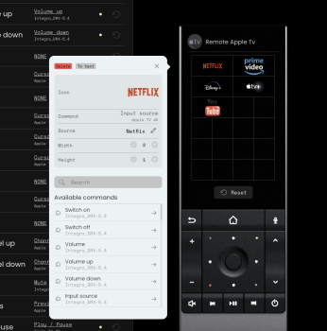

Is that normal for the input source to be typed and not selected from a dropdown menu?

va_lemon — Today at 11:10 AM

Typed in app names work but you have to make sure that it is the actual name that the integration expects. Sometimes the displayed name is different than what the integration expects. E.g. Apple TV+ is just TV. Showtime is Showtime Anytime.

va_lemon — Today at 11:18 AM

For the same question for Android TV, if you add the Android TV Input Select command to your activities On Sequence, you may see a drop down with all apps listed. That’s an easy way to get the exact name that you can type in for the App button. At least the Apple TV command has a drop down when added to On Sequence.

## Android TV

Some users have found the integration slow. Unfortunately, it's not really an Android TV integration, it's a library that acts like Android TV remote, and there's no way for this type of connection to retrieve a list of apps. Ideally, we would have an ADB connection instead (like HA does) for full control like ATV.

To get Kodi control working, go into Kodi's Addons, Peripheral Support, and disable Joystick Support AND kill/restart Kodi in order for changes to take effect. Kodi is treating Android TV IP control as a joystick (no idea why).

To get the long press button working for Android TV, especially with the OK button, there is a workaround : create a script on Home Assistant with the following code

service: remote.send_command

data:

command: ENTER

hold_secs: 0.6

target:

entity_id: remote.<your_androidtv_device>

And then import the script the remote to assign it to a button.

## FireTV

There is a bug/feature statement that AmazonTV is NOT supported by the HomeAssistant Integration. The FireTV is a SUBSET of GoogleTV and dosen't include the Remote control portion. Even rooting and adding (or sideloading) the GoogleTV compnent won't work so we need a custom integration from UF or at least BT Keyboard integration.

## Global Cache iTach Devices

The Global Cache iTach Devices were mentioned during the kickstarter campaign as devices that would be supported. The iTach hardware devices are able to bridge IP, IR, serial, and relay connections. The integration is planned for Q4, 2023, according to the [GitHub issue tracker](https://github.com/unfoldedcircle/feature-and-bug-tracker/issues/69).

## Home Assistant

### Create the connection between the remote and Home Assistant

In order to add the Home assistant integration in the remote control, first you need to create another user in order to separate the usages : go to settings > People, switch to Users tab and create a new user (ex : remote). Tick the checkbox to connect only from LAN, set a password.

Then disconnect and reconnect to Home Assistant with this new user.

Lastly, click on the bottom left to the user icon, scroll down to “Long-Lived Access Tokens” as in the screenshot below and create a new token. Be sure to copy it somewhere as it cannot be retrieved again after.

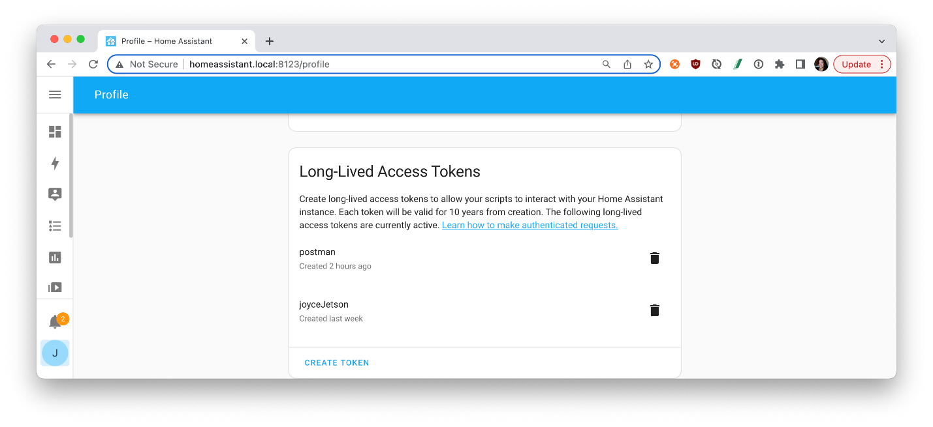

Now you can add the Home Assistant integration to your remote control.

First note the URL of your home assistant instance : by default it should be something like this URL ws://homeassistant.local:8123/api/websocket

I really advice to replace the URL with the direct IP address of your home assistant, but only if you have set it as a fixed IP from your router of course. Something like ws://192.168.0.10:8123/api/websocket

It will avoid some connections issues or delays between the remote and Home Assistant.

Also during the setup you will be asked for the token that you copied earlier.

Your integration is all setup : now you can import all the entities that you want to your remote control.

You can also import additional entities later at anytime.

Please note the following:

* At the present time you can import many entity types (but not all supported types) : lights, climates, covers, media players, switches, scripts
* Once you import entities, then you can add them directly to a page, or inside an activity
* About media player entities : this is very useful for devices that are not supported natively by the remote (RC2 supports few devices such as Android and Apple TV). So if others integrations are supported by Home assistant, you can import them in the RC2 and it will act the same way. For example, I have a Zidoo player (a media streamer) : I configured it in Home assistant, then I imported into the Remote Two. Now I can control it from the remote control and I even have the now playing thumbnail with media position/duration !
* I didn't observe any lag when processing commands from the remote : it feels like the commands are processed directly between the remote and the target device, so don’t fear to go through Home assistant to manage your devices if they are not supported by the Remote Two

### Hold action (resolved soon with firmware)

The HA integration for Apple TV also provides the “Home Hold” command which the Remote Two’s native ATV integration does not. I created a script in HA that uses the ATV integration’s remote.send_command to send home_hold command. This script then shows up as a button entity in the HA integration on the Remote Two. Bonus tip: create a macro with the Home command repeated twice. This macro when run will bring up the app switcher UI

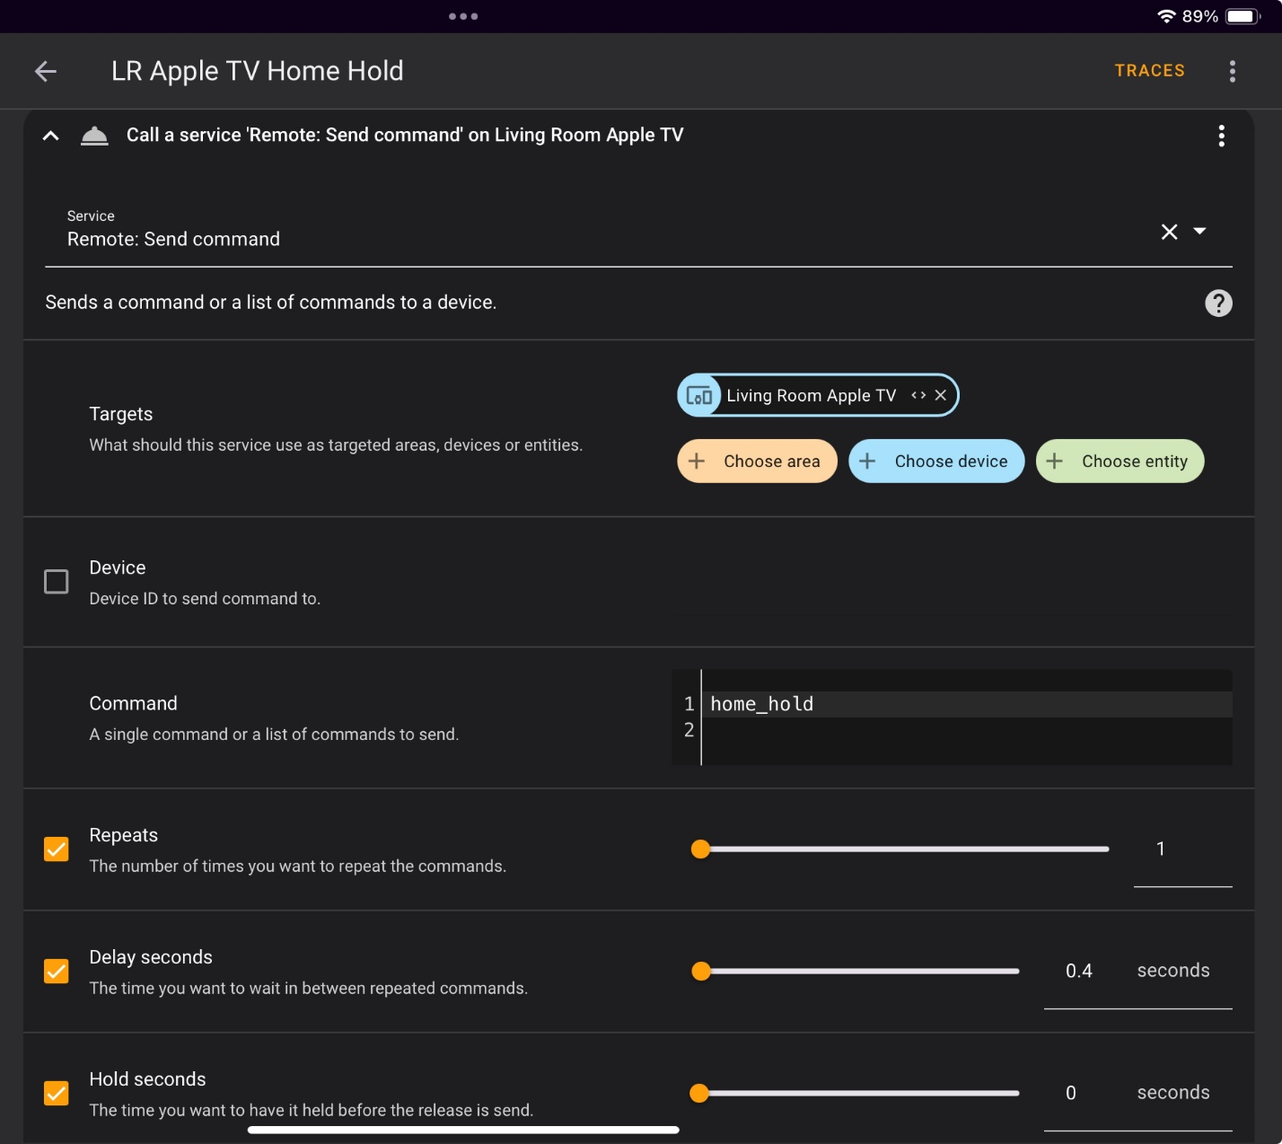 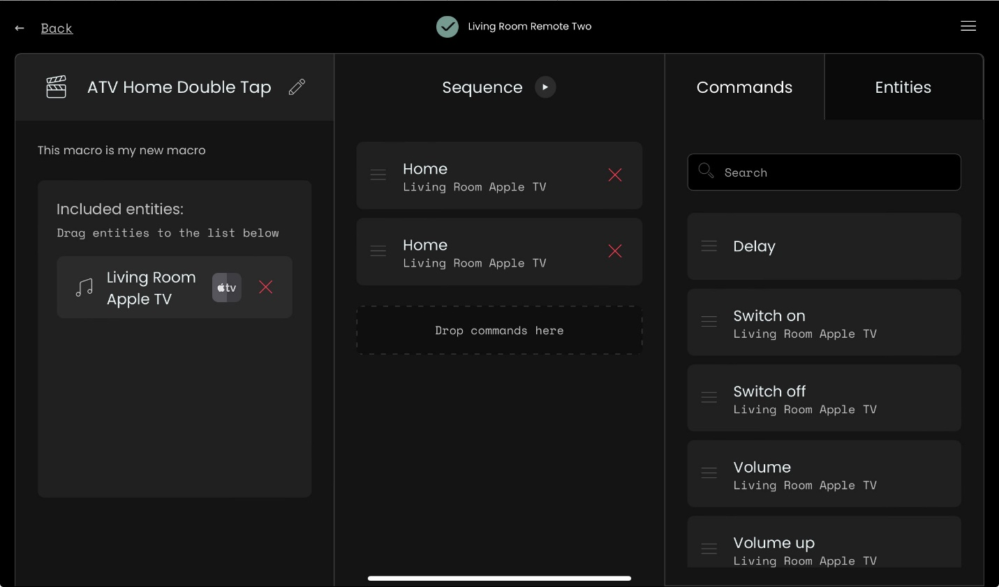

### Home Assistant integration for the Remote Two

Earlier we described how to import Home Assistant entities into your remote control.

This chapter describes the opposite way : when you want to control your Remote Two from Home Assistant, and there is a very good integration for that.

Home Assistant has been used by several users while waiting for the official integrations from the Unfolded Circle via their software roadmap.

JackPowell created a [custom Home Assistant integration](https://github.com/JackJPowell/hass-unfoldedcircle/) to interface with your Unfolded Circle Remote. It is an integration inside HA that interfaces with your Remote Two. One use case is the control of Remote Two activities with Siri voice commands or directly from Home Assistant like the Logitech Harmony integration. Below is an example of the appearance in HA.

## Roon

Some users have experienced an issue where the extension is not visible in the Roon software.

# User Interface

## Overview with an example

The user interface is structured like this :

* User profile (one by default named “Default”)
  + Page 1
    - Entity 1
    - Entity 2
    - …
  + Page 2
    - …

Let’s take a real life example :

First you defined your devices and activities (see next sections of the document)

|  |  |  |  |
| --- | --- | --- | --- |
| Activity | Activity group | Included entities/devices | Startup behavior |
| **Watch Android TV** | Living room | TV  Android TV  HT receiver | Will turn off Apple TV and STB if active |
| **Listen to music** | Living room | Apple TV  HT receiver | Will turn off TV and STB if active |
| **Watch TV** | Living room | TV  STB  HT receiver | Will turn off Android TV and Apple TV if active |
| **Watch TV** | Bedroom | TV  STB | Will turn off Bluray if active |
| **Watch Bluray** | Bedroom | TV  Bluray player | Will turn off STB if active |

Then you want to create your pages :

|  |  |  |  |  |
| --- | --- | --- | --- | --- |
| User profile | Page | Entity | Entity type | Description |
| Default | Living room | Watch AndroidTV | Activity | Starts the activity and opens the page of the activity |
| Listen to music Apple TV | Activity |
| Watch TV | Activity |
| Living room lights | Light | Opens the lights control (brightness, color) *Imported entity from Home assistant* |
| Bedroom | Watch TV | Activity | Starts the activity and opens the page of the activity |
| Watch Bluray | Activity |
| Bluray device | Device | Opens the bluray device page |
| Home | Thermostat | Thermostat | Opens the thermostat controls |
| Living room lights | Light | Opens the lights control |
| … |  |  |

You can mix different entities in a page, or only have the same kind of entities.

**One subtility**: you cannot have advanced home controls (light brightness/colors, thermostat temperature, shutter level….) inside an activity page, only in a page outside the activity.

You can still add home entities to an activity but you will only be able to set up a basic button to toggle on or off for the living room lights for example.

First, before defining the pages, you have to create the activities and activity groups eventually.

After adding integrations, next skip to the “Remotes” section if you need to add IR remotes. The “User interface” section in the web configurator is where you add or remove pages, thereby starting to customize the user interface. This portion of UI design has several levels of organization, represented by the structure below.

User Profile -> Pages -> Entities & Groups

Pages can consist of devices / entities and/or groups. Entities are the individual integrations and IR remotes that have been added. Groups allow combining the individual integrations and IR remotes, if desired.

# Activities & Macros

## Overview

After adding user profiles and pages, and define devices (either through integrations section or through remotes section), then the “Activities & macros” section in the web configurator is where you add or remove Activities, Activity Groups, and Macros. This portion of UI design has several levels of organization, represented by the structure below.

User Profile -> Pages -> Entities & Groups

## Activities

Activities can have multiple devices / entities assigned, and then each button can be assigned to any function from any of the devices. Each activity has both an on and off sequence that can be defined. For example, the Watch TV activity does the following for the on-sequence:

1. Turns on the TV
2. Turns on the cable box
3. Turns on the amplifier
4. Delay 5 seconds
5. Switches the TV to HDMI1

First you create an activity by defining its name and the devices (entities) you want to use within. You can modify an activity later if you want to add or remove entities.

The first thing to take care of is to define the startup and shutdown sequence, especially if you intend to use activity groups :

* It is recommended to use LAN integrations (Home assistant, Apple TV…) over IR devices generally (more reactive, the remote handles itself the commands instead of IR commands processed through the dock)
* When adding IR devices, be sure to define commands named EXACTLY like this : POWER_ON for power up command, POWER_OFF for power off sequence 🡺 the commands names are defined in the remote section. These special names are recognized by the remote during the power on and power off sequences of the activities
* If your IR remote doesn’t have any ON/OFF button but just a power toggle button : just duplicate the command twice with the POWER_ON and POWER_OFF labels

After that you can define the user interface of the activity which will be shown as soon as you power up the activity.

### [Activity groups](https://github.com/unfoldedcircle/feature-and-bug-tracker/issues/64)

Activity groups are a way of linking activities together as the Logitech Harmony would do, so the included entities' states are handled together when switching between activities in a group.

For example, you can create an activity group with all the activities of your living room, and another group for the activities of your bedroom. When you switch from activity to another, the active devices in both activities will remain on whereas the others will be turned off. You can change this behavior to keep running devices active also.

When you turn off the activity with the power button instead of switching to another activity, all the active devices of the activity group will be turned off.

First you have to create the activities then include them in an activity group. One activity can be added to only one activity group, which makes sense but when you have the same devices in 2 different rooms, so in 2 different activity groups, you have to duplicate the activities then.

### Macros

Macros contain a list of commands from a given entity assigned to the macro. As noted in the web configurator, the entities desired are added first, and then the commands for the entities added will be available to select from the commands list.

# Tips

## General Tips

To show the battery percentage via a long press tap on the battery symbol.

To download or backups icons, Its included in the backup. Just add .zip to the filename and you can extract it.

## New Ideas

There's a tracker to use for ideas: <https://github.com/unfoldedcircle/feature-and-bug-tracker/issues>

# UI Design

## Introduction

Icons must be 90x90 pixels in size. Ideally, they should transparent, but this is not required.

## Icon Sources

A Remote Two user (Weby on Discord) created a location to collect icons for the Remote Two, located here: <https://cockatoo.cloud/s/FC67KAiRAJWFHQY> There are some folders for icons by country; as of 11/19/23, it seems to be focused on European countries.

Some have already been formatted to work with the Remote Two. If you want to contribute missing items to the library, drop icons here: <https://cockatoo.cloud/s/DCibWiAmcZmB9bi> then DM Weby to let him know.

I used <https://www.flaticon.com/> and <https://fonts.google.com/icons> to find icons and modified them for my needs.

Mdi icons will be a good idea too : <https://pictogrammers.com/library/mdi/>. Little question how do you convert flaticon to transparent png 90x90 ?

<https://icons8.de/> allows downloading icons with an undefined format like 90x90.

## Modifying Icons

The [squoosh](https://github.com/GoogleChromeLabs/squoosh) app is a free, open-source tool that can be used to make icons smaller. The app runs in a browser.

For making transparent PNGs, I use Photoshop to select the white outer edges, delete the white parts, and save as PNG. I think most any image editor should be able to do this. There may even be online tools that could convert to transparent PNG.

## Deleting Icons

In the web configurator under Settings->Remote->Resources you can delete custom icons you no longer need.

## Page Design

For end users coming from remote controls with number buttons on them, using channel icons for the most-used channels and a separate number button page with 10 text buttons on a page.

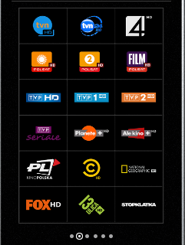 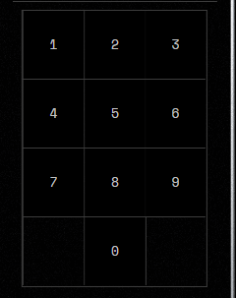

Here is mine with screenshots and icons used. I have two remotes, one in the living room and one in the home theater. I use the native Apple TV and Sonos integrations as well as Home Assistant to control a LG TV, Apple TVs, TiVos, Sonos Arc, JVC projector, Denon AVR, HTPC running MadVR, Zidoo streamer, Oppo 4k disc player, PS5 and PS3 (using IR2BT). All devices except PS3 are currently using IP commands only. The screenshots here are just for my living room setup. I used <https://www.flaticon.com/> and <https://fonts.google.com/icons> to find icons and modified them for my needs.

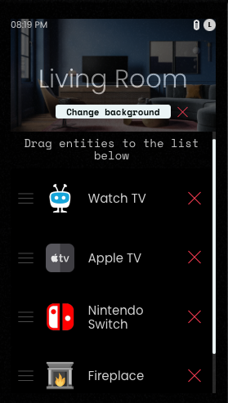 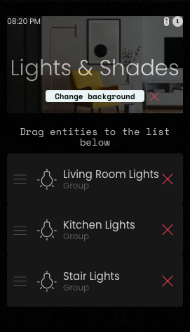 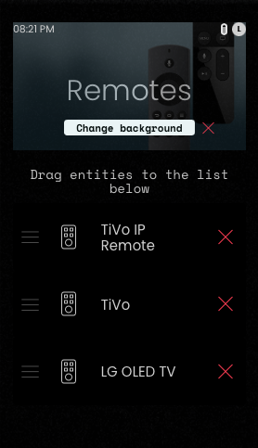

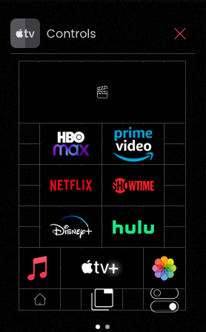 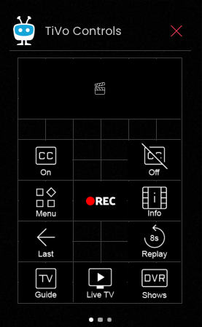 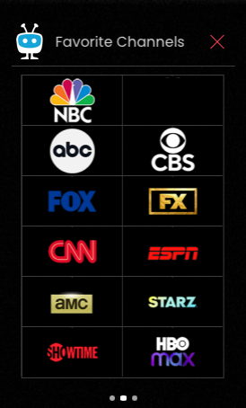

# Remotes (Infrared)

## Process Overview

so you need to go Remotes

Search for your manufacturer or you can create a blank one and enter the information

then when you get to next screen you'll see the remote itself followed by button mapping, components, pages, etc

in the upper left-hand corner click on the pencil icon next to IR data set

from this screen you can set a button name

then choose add custom button

then on the Add IR code screen you set a format, and then click Start Learning

you'll see a green light go on on your dock

press the corresponding button on your remote and you should see a code automatically entered on that screen

You will first need to add all three of your devices (TV, soundbar, internet radio) as three separate IR Remotes under the remotes section. Then go to the User Interface section of the web configurator, create a new page and add all three remotes to that page. Now you can test to make sure that the IR commands for all three devices work. After this, you can create an Activity where you can create a power on and off sequence combining multiple devices (e.g. turn on TV, turn on soundbar, change input on TV, set soundbar volume etc). Please note that before you can use any commands in an activity, you first have to search for your device next Entities and add it to your activity.

Ok, but I need to add each button from each remote manually, via IR code learning (adding custom buttons)?

Yes. You can also search for the manufacturer to see if your device or something close to it already exists in the Remote Two database. Another option is to obtain IR code sets from https://irdb.globalcache.com/ and upload these sets to the remote.

Most should be supported either by hex or pronto. There are some nasty protocols where there really may be an issue to generate correct commands. Learning them from the original remote is the bigger issue and there's going to be much more protocols which are not recognised properly.

Raw Pronto (with 0000 as first value) can actually store any IR sequence, as it just contains a set of timings when the signal should be on and off

The problem is with protocols which toggle some bits every other button press (raw Pronto can't do that) and how strict is the receiver with these bits not being toggled

## CSV Files Explained

A Comma Separated Value (CSV) file format is a text file format that uses commas to separate values. A CSV file stores tabular data (numbers and text) in plain text, where each line of the file typically represents one data record, and the data is separated by a comma “,”. Each record consists of the same number of fields, and these are separated by commas. When creating a CSV file, the separator is selectable during import, but the comma "," is the default. CSV files can be created using Apple Numbers, Google Sheets, or Microsoft Excel.

## CSV File Configuration

IR codes a user locates online can be formatted and imported to the Remote Two using a Comma Separated Value (CSV) file format. The CSV minimum formatting requirements for importing new code sets into the Remote Two are below.

Column 1 header: "key"

Column 2 header: "code"

Column 1 (key) - is the name of the key for use in the configuration, and it must be unique.

Column 2 (code) is the actual IR code data string.

Below is an example of a properly formatted CSV file used for importing into the Remote Two. To prevent confusion, two possible data formats are shown for the same exact command.

|  |  |
| --- | --- |
| key | code |
| PowerToggle | 3;0x7E8154AB;32;0 |
| PowerToggle | 0000 006D 0022 0002 0155 00AA 0015 0015 0015 0040 0015 0040 0015 0040 0015 0040 0015 0040 0015 0040 0015 0015 0015 0040 0015 0015 0015 0015 0015 0015 0015 0015 0015 0015 0015 0015 0015 0040 0015 0015 0015 0015 0015 0040 0015 0015 0015 0040 0015 0015 0015 0040 0015 0015 0015 0040 0015 0040 0015 0015 0015 0040 0015 0015 0015 0040 0015 0015 0015 0040 0015 05ED 0155 0055 0015 0E47 |

The first command above is a manufacturer IR code learned from a device remote control. The second command above is the same IR code converted to Pronto hex. Pronto hex is a notation used by the Philips Pronto universal remote, which is a series of hex numbers, for example: 0000 0070 0003 0002 0006 0002 0004 0002 0004 0006 0006 0003 0003 000С

Note that when exporting an IR code set from Remote Two, there is an additional column called “format”, so if you receive a pre-formatted CSV file that was exported from Remote Two, the “format” column will be present.

## Converting URC MXD files

If it's readable as text file, it should be easy to write a short script to convert it to a csv file that can be imported in the configurator.

[IrScruntinizer](https://github.com/bengtmartensson/IrScrutinizer) is open source software, which can both analyze and generate IR signals in various formats. This may be able to convert the URC .mxd files to a compatible Pronto format or CSV.

## IrScruntinizer Tips

Since may be challenging to use for a novice, here are some tips.

The easiest way to use it is to copy some existing pronto code into top text area in the "Scrutinize signal" tab, then press Scrutinize button. This will decode pronto code and display wave form and, if the protocol is recognized, it will also display in "Decode" field both the protocol name and its parameters.

For example, I've copied the code given by MarcO few days ago: 0000 0073 000E 0000 0020 0020 0040 0040 0040 0020 0020 0020 0020 0020 0020 00C0 0040 0020 0020 0040 0040 0040 0040 0040 0020 0020 0020 0020 0040 0040 0020 09b7 which I've pasted into IrScrutinizer and pressed Scrutinize. It recognized the protocol and parameters: RC5x: {D=16,S=37,F=29}, beg=0, end=27, reps=1 which means: Protocol: RC5x Device: 16 Subdevice: 37 Function: 29

So now if you want to generate pronto code for any function id, go to Render tab, select RC5x protocol, set D to 16, S to 37 and F to any value (0-255) you want to generate and press Render (edited)

It will render the signal as new pronto code

If you're not getting pronto, but something else, then go to Options menu and change Output Text Format to Pronto Hex (but this should be default) (edited)

## Global Cache IR Codes

This is a quite good IR database: <https://irdb.globalcache.com/Home/Database>

Registration is required, and there is a daily limit for codes, so make sure to download complete sets instead of single codes.

When receiving codes from Global Cache, save the content of the mail as a csv file and replace „function“ with „key“ and „hexcode1“ with „code“ in the first line.

Actually, the email you receive is a valid csv file. Just open in Excel/Calc, remove all columns except function and hexcode1 and remove the new lines from the cells. Save again as csv and import into remote 2

In the csv file I deleted all of the hexcode1, code2, hexcode2 columns and renamed "function" to "key" and "code1" to "code". So to be clear, when I had finished I had only two columns in the csv file with the titles "key" and "code".

## Importing Remote Codes

Remotes/+/Create blank/Enter a name and click on Create/Click on the pen in the top left corner right next to the name you entered before/Bulk import/Select a file.

## Learning Remote Codes

In the Remotes section select a remote or add a remote. Once selected click on the ir data set edit icon. On the next page click on the Button Name and name it. Then select Add Custom Button and follow the instructions to learn the IR code.

**IR Code Repository**

Until UF starts their own repository, and end user created one on Github. These codes have already been converted to work on the Remote Two, located here: <https://github.com/mattgruter/unfoldedcircle-ircodes>

## Tip for discrete commands

The remote control has only one button for play/pause but some IR remotes have 2 separate physical buttons. The expected behavior would be that the play button of the Remote Two will send alternatively Play and pause commands.

This is possible through the following tip given in the forum: <https://unfolded.community/t/tip-unorthodox-use-case-for-toggle-bit-commands-1-6-0/1332>

Let’s say that you have already leaned or defined the IR command for PLAY and another one for PAUSE.

Just create a new command named PLAY_PAUSE, select PRONTO format, and concat the 2 sequences copied from PLAY and PAUSE commands by inserting a pipe “|” between the two.

# APIs

The Remote Two has a set of [core APIs](https://github.com/unfoldedcircle/core-api) posted on github .

You can also have access to the API documentation directly through the remote IP http://<your_remote_ip>

Here is a Python script that :

1. Logins to the remote through basic authentication with the 4 digits PIN code
2. Create an API key in the remote : the API key will replace the PIN code authentication (which changes) and is necessary to use the websocket
3. Connects to the websocket and subscribes to events, and displays the events on the screen

Just modify the beginning of the script :

hostname = "<remote IP>"

username = "web-configurator" 🡸 don’t change

password = "<pin code>"



You may have to install modules through pip install <module name> to make the script work.

Then : python test.py

## REST

The pin works with username "web-configurator".

To use most commands you need to be authenticated. You can do this either by using /pub/login, which generates a session cookie, or you can just use http basic auth:

username is web-configurator

password is your web configurator pin

Here's an example of sending a reboot command to Remote Two using curl:

curl -X POST "http://REMOTE_IP_ADDRESS/api/system?cmd=REBOOT" -u "web-configurator:YOUR_PIN" -H "accept: application/json" -d ""

# Maintenance

The Remote Two has the capability for the end user to replace parts, such as the battery and the display.

## Replacing the battery

The [LiPo Battery LP4141110](https://www.lipobattery.us/lipo-battery-lp4141110-3-7v-2400mah-8-88wh-with-protection-circuit-and-wires-50mm-and-jst-achr-02v-s/) 3.7V 2400mAh 8.88Wh ([specifications](https://www.lithium-polymer-akkus.de/wp-content/uploads/2022/07/LP4141110-2400mAh-with-JST-ACHR-02V-S.pdf)) has an expected cycle life @(0.5C/0.5C)@23±5°C) 500 cycles ≥ 80%. To remove the battery, on the back of the remote control, press the pinhole in the center to remove the back cover. The connector & blue pull tab are visible on the right.

